Texas Healthcare Data Privacy Analysis of Google Gemini AI

Group 1
Hudson Cole, Michael Garza, Natalia Hernandez, Samuel Hilliard
Collin College
CYBR 4350-003: Senior Project
Manny Hameed
May 10, 2026

Table of Contents

Project Topic 2
Problem Statement 2
Project Summary 2
Assumptions 4
Proposed Technology-Enabled Security Solution 4
Context and Rationale 4
Objectives and Expected Outcomes 5
Stakeholder 5
Relevance to Cybersecurity 6
Literature Review 6
Implementation Plan 8
Environment Setup 10
Detail Diagrams, Methodologies, Technologies 10
Data Collection Logs and Results 12
Project Completion Date 13
Mapped BAT Courses 14
Annotated Bibliography 16
Questions & Answers 23
Appendix A – Acronyms and Abbreviations 24
Appendix B - Definitions 25
Appendix C – References 26
Appendix D – Collaboration 28
Appendix E – Additional Relevant Diagram 28

Project Topic
The scope of the project is to investigate how privacy is managed through a new Artificial Intelligence (AI) technology (Google's Gemini Ai) within the Texas healthcare industry. The project will test data that is owned and/or managed by healthcare providers to see if they adhere to the privacy policies set by risk and compliance frameworks. Confidentiality is scoped, as this will ensure that the organization understands where and who will have access to its data. Integrity is in scope as that wherever the data exists that the data storage or transit is appropriately following compliance.

Problem Statement
Healthcare providers adopting artificial intelligence technologies such as Google Gemini face significant security, privacy, and governance challenges related to the management of sensitive patient data. The integration of AI systems raises questions about how sensitive patient data is collected, processed, and protected within healthcare environments. Facilities like hospitals must determine what administrative controls are available to IT personnel to safeguard protected health information (PHI), who holds legal authorization to access or utilize the collected data, and how data is protected while at rest and in transit. Additionally, these providers must assess whether current data governance and retention practices align with current regulatory standards and emerging AI compliance frameworks.

Project Summary
The privacy and security evaluation through a three-phase checklist. This setup will facilitate networking of virtual machines (VMs) on a local server to test the performance and security of Gemini Ai. The project plan will deal with a data privacy evaluation through a three-phase checklist.
- The project will evaluate how effectively Google Gemini collects, processes, and shares data by analyzing publicly available documentation and other open-source information.
- This project will use a custom-built lab environment, complete with all required host machines and networking capabilities, to emulate a healthcare enterprise network environment and run simulated traffic through Google Gemini to determine how this information is processed.
- The project will assess how transparent Google Gemini is in handling data and whether it complies with privacy regulations, including the Texas Data Privacy and Security Act (TDPSA), the Health Insurance Portability and Accountability Act (HIPAA), and the Texas Medical Records Privacy Act (TMRPA/HB 300).

Our project evaluation testing phases will answer frequent questions regarding how data is managed within healthcare providers. We will accomplish this by working towards an observation and testing perspective involving assessing privacy and security risks associated with AI-enabled healthcare systems. Our evaluation will provide insight into the criteria for AI transparency, IT admins handling practices, and processes of handling practices. This will allow stakeholders to make informed approval decisions. Organizations can then decide what to do with the given information and continue to proactively manage privacy risks and ensure responsible use of AI within healthcare environments within the state of Texas.

Assumptions
This implementation will cost organizational run time, such as personnel to maintain the server's operating system updates and software updates. This also includes organizational driven software, software licenses, and support licenses. The cost is associated with purchasing servers VMs, MITMProxy license and its support cost, third party regulatory review costs, and data management. This lab set up also assumes an environment centered around a healthcare enterprise, with DLP filtering being centered around keywords associated with this, like scenario patient names, employee information, and keywords involving healthcare and billing.

Proposed Technology-Enabled Security Solution
MITMProxy is an in-network data loss prevention (DLP) solution. It acts as a transparent inspection point to audit HTTPS traffic in-transit for privacy compliance. MITMProxy also enables our team to monitor and conduct encrypted traffic analysis.

Context and Rationale
In modern enterprise environments, agentic AI is becoming increasingly prevalent in the form of automation processes and enterprise-specific systems, including generative chatbots. While these represent the potential for a boom in productivity, AI agents can also represent the possibility for data leakage as much of the data these agents' processes are also used to train AI engineers' models further. This project will provide ways organizations can manage risks associated with data collection and processing controls, technical testing, and compliance measures to help ensure the privacy and security of all data.

Objectives and Expected Outcomes
This project aims to encourage healthcare providers to fully leverage AI capabilities such as clinical and analytical purpose-built tools and automations, when managing patient records, while maintaining strong security, privacy protections, and regulatory compliance when using technologies like Google Gemini.
The objective of this study is to evaluate how healthcare organizations can securely integrate AI technologies while safeguarding sensitive patient information. This analysis will examine the security controls, administrative oversight, and governance policies required to manage patient data throughout its lifecycle, including collection, processing, storage, and transmission. It will also assess how organizations regulate data access and comply with local, state, and federal regulations governing PHI.
The expected outcome is to identify best practices and governance strategies that support the responsible use of AI in healthcare environments. These findings will focus on strengthening data protection measures, establishing effective data retention practices, and ensuring regulatory compliance while enabling healthcare providers to benefit from AI-driven technologies.

Stakeholder
Our project stakeholders include executives, investors, privacy/legal and compliance teams, and DevOps. Executives set the direction and approval for the organization and how future technologies will help the organization. Investors provide capital for business improvements such as for this effort. Privacy/legal aids in ensuring vendor engagement and software are being used as defined in signed business agreements. Compliance teams aid in ensuring new tech and strategies align to risk and governance. DevOps aid in ensuring this effort is following modern and automated processes to streamline development and production deployments without negatively impacting the organization.

Relevance to Cybersecurity
This project highlights the importance of managing the ingress and egress of data, especially as organizations begin using AI technologies like Google Gemini. In this context, data ingress refers to the sensitive information that enters a system or AI model, such as patient records or clinical data submitted for analysis (What is Data Egress? Ingress vs. Egress). Data egress refers to any information that leaves the system, including AI-generated outputs, transmitted records, or stored logs (What is Data Egress? Ingress vs. Egress). From a cybersecurity perspective, monitoring these data flows is critical because improper handling can lead to data exposure, unauthorized sharing, or misuse of PHI. By controlling what data enters and leaves AI systems, organizations can better enforce security policies and prevent data leaks with healthcare privacy regulations while safely adopting AI technologies.

Literature Review
Security and Privacy of Generative AI in Healthcare
The use of AI, such as Google’s Gemini Ai, in Healthcare organizations presents a complex issue where clinical utility and data vulnerability meet which begs the question of how security and privacy are balanced. AI models offer significant advancements in processing medical/clinical data, but simultaneously expand attack surfaces regarding data collection, user authentication, and compliance. Our groups' literature review intends to synthesize current research related to mobile security, user trust in AI systems, and inherent technical vulnerabilities in modern data management.
The Complexity of Privacy & Security in Data Collection
Managing data at rest and in transit within an AI framework demands a delicate balance between system functionality and privacy for users. Chassidim et al. identifies a significant "trade-off" where users must decide between the privacy-invading nature of security applications versus the protection they offer (2021). In healthcare, this issue is particularly apparent. Yener et al. argued that while AI chatbots are becoming central to data collection, patients and providers often remain unaware of the underlying data retention and processing protocols (2025). This lack of transparency is compounded by issues in mobile application security. Li et al. highlights that many applications fail to implement standard privacy guards, particularly when guarding machine learning models that connect with cloud resources (2024). Additionally, as healthcare organizations integrate Gemini Ai, the necessity of maintaining data compliance requires transitioning past basic application security towards more “private processing” models currently being used in other generative AI sectors (Shah, 2025).
Challenges of Authorization and Authentication
It’s imperative to determine who has legal authority to access and utilize collected data. Traditional authentication methods in mobile environments, such as simple passwords, have been increasingly viewed as insufficient for securing critical confidential health data. (Zukarnain et al., 2022). To solve the issue of burnout for users that feel some more stringent methods of authentication can be exhausting, Jayaram et al. proposed a novel method of authentication known as “copresence detection” (2025). Where a dynamic acoustic fingerprint is used to verify that a user is truly in proximity to an authenticating device, healthcare providers could theoretically access Gemini Ai interfaces securely without the hinderances of traditional multi-factor authentication (MFA). This approach to authentication could directly address security needs and user exhaustion while ensuring effective access control only is provided to authorized personnel.
Infrastructure Vulnerabilities and Infiltration Risks
AI presents unique challenges to security when managing data at rest, as well as the speed and efficiency of the environment are often prioritized over security. For example, while VMware offers accelerated performance for virtual machines, the complexity of these systems can still be targeted by sophisticated malware (GNS3 Documentation, n.d.). Moreover, Vasilellis et al.’s work demonstrates that even seemingly benign applications can serve as a covert channel for polymorphic-trojan attacks. So, in a healthcare setting such an attack could potentially bypass modern defense postures to capture sensitive AI-processed data. This underscores the importance of security controls that can effectively interrogate AI’s data-at-rest protocols.
Finally, based on the research our team has analyzed, it appears to confirm how security challenges respective of using Generative AI in healthcare are not merely theoretical but rooted in the existing mobile and virtualization vulnerabilities. While there has been significant progress in new authentication methods and private data processing, like our research has covered, the need for a security solution that specifically address Gemini Ai’s data retention and legal authorization protocols within the healthcare industry, remains critical.

Implementation Plan
We conducted a data-centered privacy evaluation of Gemini Ai. We researched today’s healthcare industry data standards and applied them to our findings. We then accessed Google's Ai Gemini chatbot to see how it handles data privacy with the help of MITMProxy. We confirmed whether it is following privacy and security frameworks such as the TDPSA, HIPAA in the state of Texas, within the Healthcare industry and their data policies.
This project conducted a data-centered privacy and security evaluation of Google Gemini to better understand how AI tools manage sensitive healthcare patient data. The research began by reviewing current hospital data privacy regulations that govern the handling of PHI.
Next, we accessed Google Gemini in a controlled virtual environment and analyzed how it processes and handles data. To support this testing, we used an open-source tool called MITMProxy, a TLS terminating proxy to determine how Google Gemini behaves alongside how it works in a traditional proxy-based data loss prevention (DLP) environment.
Our findings were then be compared against state regulations such as the TDPSA, HIPAA, and the TMRPA/HB 300. HIPAA establishes federal standards for protecting PHI through safeguards such as access controls and secure data handling, while the TDPSA outlines broader consumer data privacy rights and security expectations for organizations handling personal data in Texas. TMRPA expands on HIPAA requirements within Texas by applying stricter privacy protections and training requirements for anyone handling medical records, making it especially relevant for evaluating how AI systems interact with patient information.
Finally, the project will produce a report summarizing the results of the evaluation and identifying best practices for managing privacy and security risks when implementing AI technologies in healthcare environments.

Environment Setup
Step 1: A GNS3 environment will be created involving 2 machines; an open-source router called VyOS Router and an Ubuntu Desktop. This will all run on a Lenovo ThinkPad, which can more than accommodate the resource requirements for this in GNS3.
Step 2: MiTMProxy will be configured with DLP instructions to filter certain healthcare related keywords to be run on the Ubuntu Desktop.
Step 3: A simulation will begin where the user will simulate traffic on the Google Gemini web-based traffic. Specific queries will be used to trip the DLP system in MITMProxy, which will give information about how the information was used and where it was sent.
Step 4: An analysis of MiTMProxy logs will determine what data can be stolen by an adversary and what data will be sent back to Google.

Detail Diagrams, Methodologies, Technologies
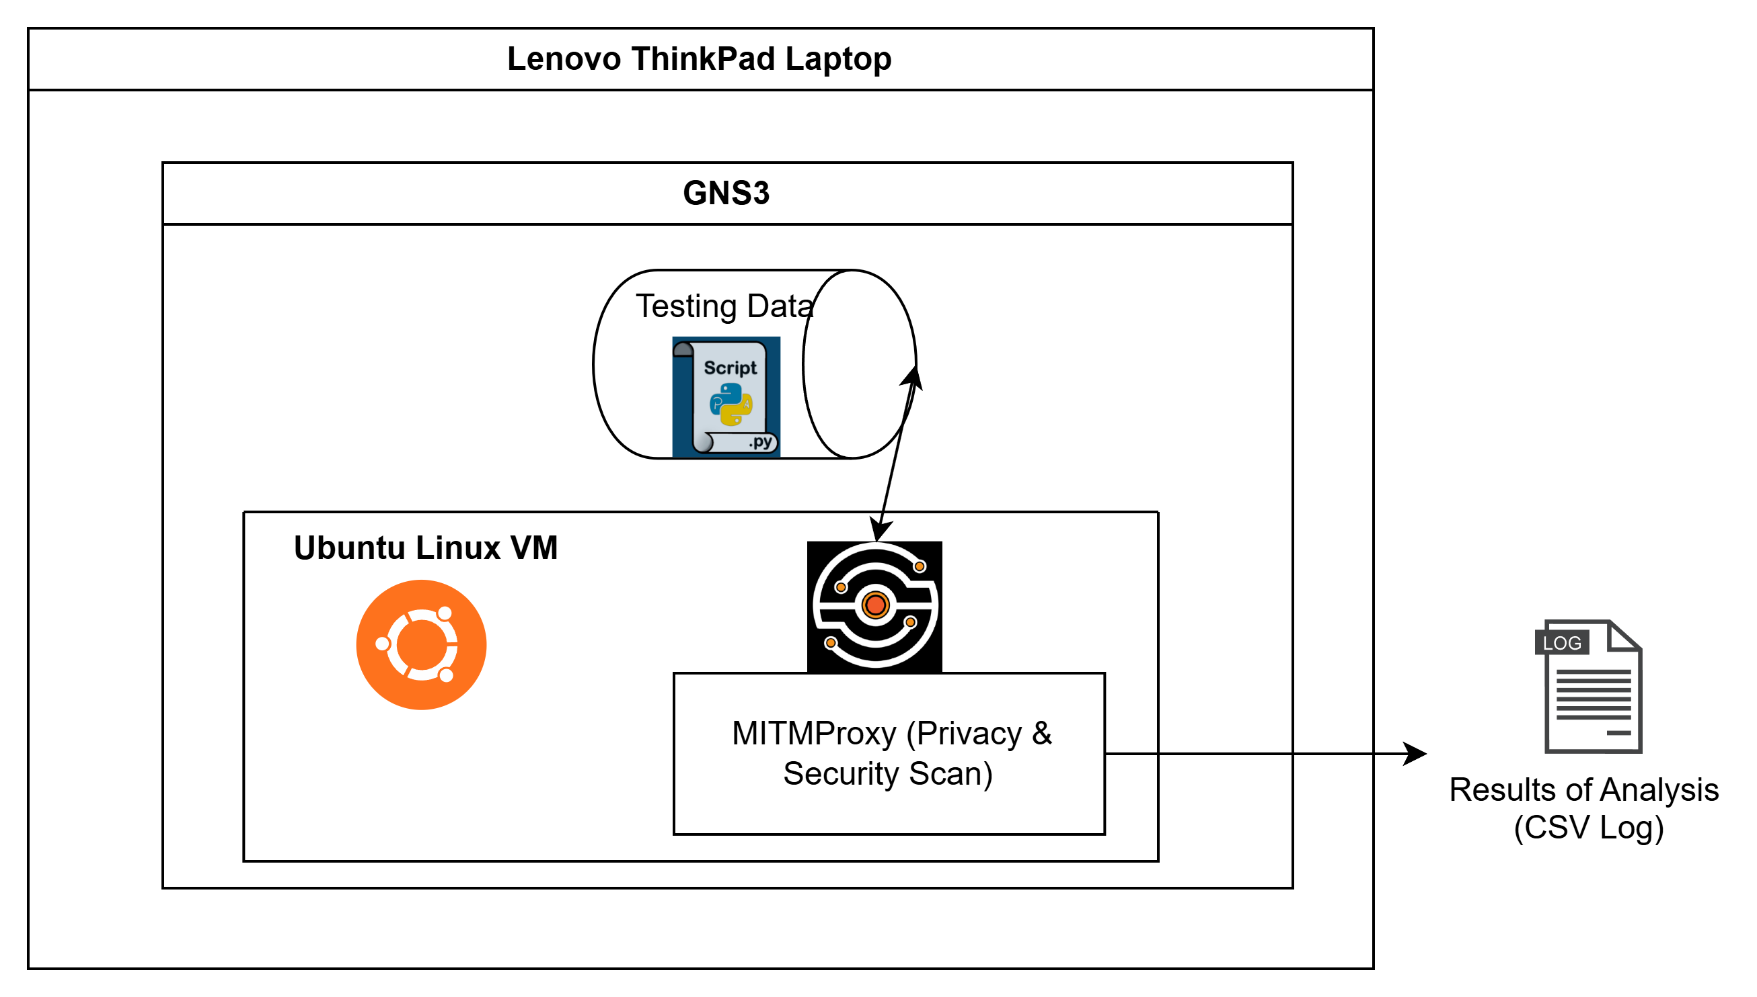
Figure 1. Above figure shows Phase 2 Testing Diagram
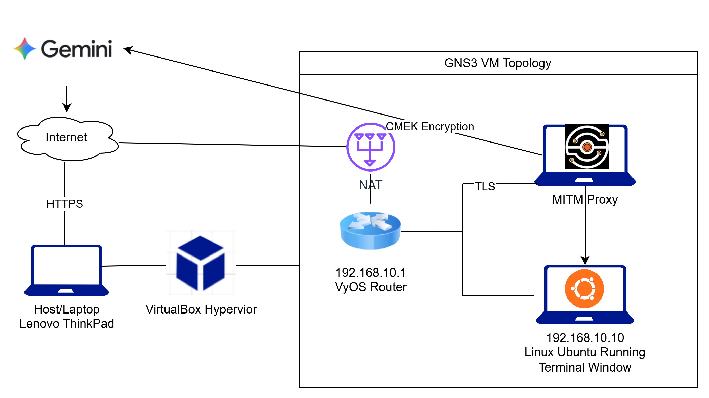
Figure 2. Above figure shows Project Virtual Machines Testing Environment

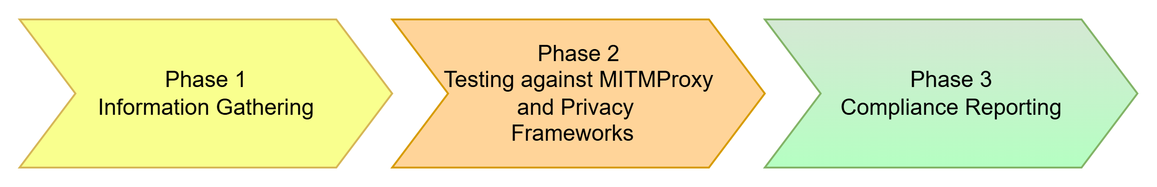
Figure 3. Above figure shows the Three Evaluation Phases of Gemini Ai

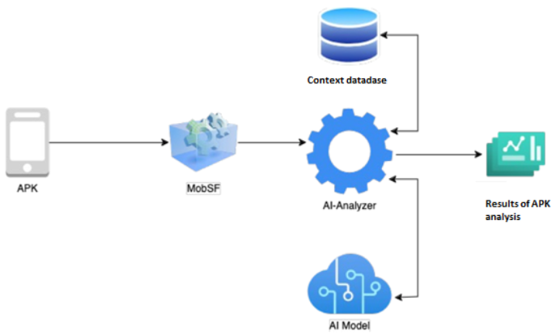
Figure 4. Above figure shows MiTMProxy Case Example (Automated Testing of Android Device)

Data Collection Logs and Results
Our data source consisted of collecting network traffic from MITMProxy application into a CSV file. This file is the result of running MITMProxy on an instance where there is data being input into a Gemini Ai Chatbot. It should contain the same data that was inputted into the Chatbot as proof that we are able to see where and what occurred to this data, further supporting our privacy evaluation on Gemini Ai.
The File format is a CSV file: Full_Logs.csv. It has been uploaded into SharePoint file /Instructor’s Team Site. A screencap of the demonstration and a DLP script log are also uploaded to prove the script is working properly: Demo Screencap.mkv, dlp_log.csv.
There were a few instances where we were not receiving data on the other end of MITMProxy. Despite changing multiple technical efforts, we came across the same problem. We believe this new finding has to do with a certain Gemini Ai policy or the way the Gemini API behaves in proxied environments. This limitation would help us further understand Ai model boundaries.

Project Completion Date
The project was completed on April 26, 2026. Project is scheduled to be presented to stakeholder and business leaders on May 7th, 2026.
- Week 1-3: Brainstormed and created project proposals.
- Week 4-6: Began setting collaboration cadence and standing up project environment.
- Week 7-10: Meet with Professor with a 1 on 1 and as a group to get guidance on our project. Provided a showcase demo.
- Week 11-13: Submitted logs, implemented changes as suggested by the professor and group recommendation.
- Week 14-16: Finalized presented report and present to the stakeholders and business leaders.

Mapped BAT Courses
CYBR 3350 - Cyber Privacy: This project is, at its core, a question of privacy. This project will neatly align itself with the goal of understanding privacy law and proper data management.
CYBR 3360 - Mobile Technologies: AI systems are accessed through various methods, including through mobile devices, which are ubiquitous in modern American society. Our Mobile Technologies course aligns with our project because these devices are integral to modern security concerns, thusly their respective frameworks and security implications.
CYBR 4340 - Information Assurance: Along with the focus on privacy and data management, this will also show an understanding of data governance. This is because governance and regulation are inherently tied.
CYBR 4310 - Penetration Testing: This class will also rely on penetration testing knowledge. It will use concepts like on-path attacks and tools like Wireshark
CYBR 4330 - Virtualization & Cloud Security: This will also heavily rely on virtualization. GNS3 is a front-end emulation software and will require concepts like resource sharing and cloud networking to function properly.
ITCC 1314 - CCNA 1: Intro to Networks: Alongside the virtualization concepts, this lab requires an intimate understanding of basic networking concepts, like common protocols and networking devices.
ITCC 1344 - CCNA 2 Switch Route Wireless Essentials: This lab will require the use of networking concepts like VLANs and routing. These are easily handled in this class
ITSC 1316 - Linux Install & Configuration: This class will also make heavy use of Linux for its open-source nature, lack of licensing requirements and low resource profile/overhead.
Report/Conclusion
Our overall evaluation consists of a three-phase checklist on the following findings:

1. After researching open-source information, we found that a discrepancy between TDPSA and Google’s Gemini AI. Our group discovered lawsuits alleging Gemini data handling practices may at times conflict with Texas data privacy regulations. TDPSA requires transparency, opt-in consent, and data purpose limitations. Our group focused on whether Gemini can safely and effectively handle test-data meant to represent medical patient data while maintaining privacy standards in-line with the TDPSA regulations.
2. This project’s data found that these AI web based chatbots will actively evade the traditional, host based DLP proxy-based solutions such as MITMProxy. This means that these solutions are ineffective for modern environments. More complex DLP solutions involving active host monitoring must be implemented to prevent leakages from web based chatbots.
3. Google Gemini used as a consumer is not HIPAA complaint but when used with Google Workspace, Gemini can support HIPAA (Google Workspace and Cloud Identity HIPAA Implementation, 2025). With regards to if Google Gemini is compliant with TDPSA, is dependent on Gemini is implemented, as there is no public confirmation that Google Gemini is compliant with TDPSA (State Bar of Texas | Articles, 2025). Following the initial implementation, our team discovered behaviors that allowed Google Gemini to bypass the web proxy. This behavior effectively disabled the security controls designed to monitor Google Gemini for potential exposure of HIPAA or TDPSA related data. Similar to TDPSA, Google Gemini will comply with TMRPA/HB 300 as long as it is used with Google Workspace.
The three-phase evaluation identified key privacy and security gaps in how Google Gemini may be used within healthcare contexts. Open-source research revealed potential conflicts between Gemini’s data handling practices and Texas Data Privacy and Security Act (TDPSA) requirements for transparency, consent, and purpose limitation, raising concerns about whether it can safely process test data modeled after patient information. Lab testing showed that web-based AI chatbots like Gemini can bypass traditional proxy-based DLP tools such as mitmproxy, indicating these controls are insufficient without more advanced host-level monitoring. Finally, the assessment found that Gemini is not HIPAA-compliant in consumer use but can support compliance when deployed within Google Workspace and Cloud Identity; TDPSA and TMRPA/HB 300 alignment similarly depends on how Gemini is implemented, with no public confirmation of default compliance.

Annotated Bibliography
Chassidim, H., Perentis, C., Toch, E., & Lepri, B. (2021). Between privacy and security: the factors that drive intentions to use cyber-security applications. Behaviour & Information Technology, 40(16), 1769–1783. https://doi-org.library.collin.edu/10.1080/0144929X.2020.1781259
This article by Hadis Chassidim, et al. explains how their research focused on studying the relationship between mobile data privacy offered by security applications and the trade-off of invasion of privacy from those security solutions. The author's credibility has been determined based on their professional affiliation with the Department of Software Engineering at the Shamoon College of Engineering in Beer-Sheva, Isreal. This article appears to target an audience of other academic community members who share interest in gaining insight into how users make decisions about installing security application software. Moreover, the purpose of this article was to determine the factors and elements of users decision making when selecting security application software, whether they’ll care about security balanced with privacy and how. This informative article was published on the 29th of June in 2020.
Fortinet “What Is Data Egress? Ingress vs. Egress.” Fortinet, Fortinet, www.fortinet.com/resources/cyberglossary/data-egress. Accessed 4 May 2026.
This Fortinet cyberglossary article has no formally introduced author as it is under the authorship of the organization and discusses the nuances of egress versus ingress regarding data. Its purpose is to be useful for explanation of technical terms such as ingress and egress. Additionally, it discussed the threats to data during egress as well as best practices. This article appears to benefit a target audience of technically proficient individuals concerned with the movement and security of information. This informative article has no detailed publish date.
GNS3 Documentation. (n.d.). Downloading the GNS3 VM. In GNS3 Documentation. https://docs.gns3.com/docs/getting-started/installation/download-gns3-vm/()
This GNS3 website gives instructions on how to download and install GNS3 VM for VirtualBox or VMware. According to the website, both options are fully supported, but VMware is pushed more because it’s faster and supports nested virtualization, as the VMs inside the VM are accelerated by your computer’s CPU. There will be a noticeable speed difference depending on the VM, resulting in slow speeds on VirtualBox. We will keep this in mind when running our virtualization.
Jayaram, R. S., Balajothi, D., & Natchirajan, D. (2025). Improved Mobile Security Based on Two‐Factor Authentication. Security & Privacy, 8(1), 1–17. https://doi-org.library.collin.edu/10.1002/spy2.495
This article by Raja Sekar Jayaram, et al. discusses a novel method for two-factor-authentication (TFA), in which the close proximity of background-noise around a user’s mobile phone through copresence detection and a dynamic acoustic fingerprint, which would validate whether the device is in the same presence as the user. This experimental method is being researched due to the finding of some users not using mobile TFA due to finding it exhaustive, with this research being conducted in hopes of overcoming this increasing user TFA adoption. The credibility of the author’s is affirmed by their professional affiliation with the Mepco Schlenk Engineering College of Sivakasi, India. This article appears to target an audience of fellow academics and others interested in mobile cybersecurity research and development. The article’s purpose appears to be to inform the viewers about the novel concepts of dynamic acoustic fingerprinting, or contextual copresence to determine proximity of devices for authentication purposes. This informative work was published in Security & Privacy, with respectable recency in Jan/Feb 2025.
Li, Y., Dang, X., Tian, H., Sun, T., Wang, Z., Ma, L., Klein, J., & Bissyandé, T. F. (2024). An empirical study of AI techniques in mobile applications. Journal of Systems and Software, 219, 112233. https://doi.org/10.1016/j.jss.2024.112233
This article by Li, et al. provides a large dataset of Android apps and reviews the need for mobile apps to implement common privacy guards as the articles identifies inconsistency across many mobile applications. In addition, this article identifies the need to have better information security protection for machine learning and/or deep learning models. That need for better protection being whether the analysis is executed on the mobile device itself or where the mobile application connects to cloud based resources.
Powell, B. (2025, September 2). How to Prevent AI Data Leakage and Boost Security Posture. https://www.zscaler.com/blogs/product-insights/how-to-prevent-generative-ai-data-leakage
This web article was written by Zscaler author Ben Powell, who appears to have an extensive authorship and authority in cybersecurity training and providing security insights. Mr. Powell’s work explains what AI is, key AI data security challenges, and best practices to mitigate those challenges. The author aptly points out relevant industry concerns of AI integration risks, where AI is used inappropriately and without permission of the IT department, also known as shadow AI, as well as issues in maintaining confidentiality and compliance dealing with sensitive data. This work fits effectively with our project and has seemed to be an excellent source for our work due to the concerns and concepts that were raised by the author. This article appears to target an audience of interested and concerned cybersecurity professionals and cybersecurity enthusiasts, as it is focused on the education of AI data risks and respective mitigations and controls. The purpose of this article appears to be to inform, as it provides education and best practices on AI data security risks. Finally, this body of work was accessed on March 13th, 2026, and published by Zscaler.
Professor Xai. (2025a, October 1). Beyond the hype: How Gemini’s AI API is ushering in a new era of healthcarei. Rogue Marketing. https://the-rogue-marketing.github.io/top-use-cases-of-google-gemini-ai-in-healthcare-industry/
This web article was authored by Professor Xai, whose background appeared to be undeterminable and thus, their credibility couldn’t be validated. However, the content of this article appeared to be intriguing and relevant to Gemini, specifically regarding its use in the domain of healthcare. Since the authors' credibility could not be successfully validated, this work was viewed as intriguing while simultaneously considered with appropriate professional skepticism. The work described the potential use of Gemini API in healthcare by transcribing clinical documentation, assisted medical scanning image analysis (for example, regarding x-rays, CT-scans and MRIs), acting as a pharmaceutical research assistant, and more. This web article appears to target an audience of the general public who find interest in AI advancements in healthcare, specifically regarding Gemini API. This body of works purpose appears to be to inform and excite/entertain the general public regarding the alleged advancements of AI in healthcare. This overall informative body of work was accessed on February 20th, 2026, and published by Rogue Marketing.
Shah, A. (2025). Meta adds privacy feature to WhatsApp days after US House ban. Computerworld (Online Only), 1. https://research-ebsco- com.library.collin.edu/c/xq54jv/viewer/html/ss47vjtyvb
The article discusses WhatsApp's introduction of a new privacy feature that utilizes Meta's generative AI (genAI) technology to create private summaries of unread messages for users. This feature, called "Private Processing," aims to enhance user privacy by ensuring that the summaries are not visible to unauthorized users, helping with ongoing concerns regarding privacy and security. This is great information regarding new security flaws being fixed and optimized while also leading the way to how other AI models can organize their user data.
Vasilellis, E., Botsos, V., Anagnostopoulou, A., & Gritzalis, D. (2024). Gaming the system: tetromino-based covert channel and its impact on mobile security. International Journal of Information Security, 23(4), 3007–3027. https://doi-org.library.collin.edu/10.1007/s10207-024-00875-3
This article by Efstratios Vasilellis, et al. discusses an interesting approach to malware delivery/infiltration and stealth methods to overcome security, particularly in Android operating system (OS) environments. The credibility of these authors is validated by their professional affiliations with the Athens University of Economics and Business, within the Department of Informatics, in Athens, Greece. The article delves into a covert channel attack approach that embeds malicious payloads in a seemingly benign version of the game, Tetris, known as ‘Tetromino’. Furthermore, the malware approach utilizes a polymorphic encoder, meaning it changes its code or signature each time it replicates itself, and functionally uses gamification to perform malicious payload delivery. This article appeared useful to our project because it shared leading-edge infiltration concepts that were relevant to breaching a mobile OS, Android. This article’s target audience appears to be cybersecurity academics interested in the advancement and understanding of mobile OS pen-testing approaches. This article’s purpose appears to be to educate readers on the novel polymorphic-trojan approach, capable of being levied against Android and their modern defense posture. This informative article was published in the International Journal of Information Security in August 2024.
Yener, R., Chen, G., Gumusel, E., & Bashir, M. (2025). Can I Trust This Chatbot? Assessing User Privacy in AI‐Healthcare Chatbot Applications. Proceedings of the Association for Information Science & Technology, 62(1), 809–820. https://doi-org.library.collin.edu/10.1002/pra2.1299
This article, written by Yener, Chen, Gumusel, and Bashir, presents research on Conversational Artificial Intelligence, otherwise known as “AI Chatbots” and how their collection and processing of sensitive data present critical privacy concerns. This article particularly makes an example out of healthcare chatbots that collect personal data. It aligns with our project as our concern is how AI platforms use users' data, along with their unawareness of how their personal data is processed or stored.
Zukarnain, Z. A., Muneer, A., & Ab Aziz, M. K. (2022). Authentication Securing Methods for Mobile Identity: Issues, Solutions and Challenges. Symmetry (20738994), 14(4), N.PAG. https://doi-org.library.collin.edu/10.3390/sym14040821
This article was written by Zuriati A. Zukarnain, et al. which discusses how smartphone technology today is often used in such a way that it contains many applications with confidential data/information. Furthermore, this article explores how regular mobile users authenticate using passwords and short messages, and delves into the inherent security vulnerabilities that exist while also covering the more complex authentication methods that are being used, and the identification of the best authentication method/solution. The authors of this work have their credibility validated by their professional affiliations with the Department of Communication Technology and Network at University Putra Malaysia, the Department of Computer and Information Sciences at the Universiti Teknologi PETRONAS in Malaysia, and the Centre for Research in Data Science (CERDAS) also at the Universiti Teknologi PETRONAS in Malaysia. This article appears to target an audience of academic researchers who are interested in sharing discoveries concerning mobile authentication research. This article’s purpose appears to be to inform the viewer about the vulnerabilities they discovered exist for many authentication methods and identifying the best authentication solution, while simultaneously overcoming challenges. This informative article was published with effective recency, by Symmetry in April 2022.

Questions & Answers
- Question 1: Where are the logs generated from?
  - Answer: Logs are generated in MITMProxy and aggregated into CSV files.
- Question 2: Why won’t Gemini allow your team to view certain logs and files?
  - Answer: Unfortunately, this was not something our team was certain of. Our team suspects that it could be related to an AI data privacy feature.

Appendix A – Acronyms and Abbreviations
CMEK - Customer Managed Encryption Keys
GNS3 – Graphic Networking Simulator 3
HIPAA – Health Insurance Portability and Accountability Act
TDPSA - Texas Data Privacy and Security Act
TMRPA/HB 300 - Texas Medical Records Privacy Act
DLP – Data Loss Prevention
VM - Virtual Machines
PHI - Protected Health Information
VLAN – Virtual Local Area Network
CSV Log - Comma-Separated Values Log

Appendix B - Definitions
Health Insurance Portability and Accountability Act (HIPAA) – A U.S. federal law that establishes standards for protecting sensitive patient health information from being disclosed without consent or knowledge.
TDPSA (Texas Data Privacy and Security Act) - A Texas state law that grants consumers rights over their personal data and requires organizations to be transparent about how they collect, use, store, and share that data. It mandates clear privacy notices, purpose limitation, data minimization, consumer consent (opt-in for sensitive data), and reasonable security practices for businesses operating in Texas or handling Texans’ data.
TMRPA/HB 300 (Texas Medical Records Privacy Act) - A Texas law that expands medical privacy protections beyond federal HIPAA requirements. It applies to any entity handling protected health information (PHI) in Texas, requires stricter employee training, broader definitions of covered entities, tighter authorization rules for disclosures, and stronger penalties for improper handling of medical records.
DLP (Data Loss Prevention) – Security tools and policies designed to detect, monitor, and prevent unauthorized transmission or exposure of sensitive data.
VM (Virtual Machine) – A software-based emulation of a physical computer that runs an operating system and applications in an isolated environment.
GNS3 – A popular networking simulator that allows users to create virtual environments built on virtual machines for testing purposes.
MITMProxy (MITMProxy) – An open-source intercepting proxy used to inspect, modify, and analyze network traffic between a client and a server for testing and security analysis.
PHI (Protected Health Information) – Any information about a person’s health status, medical care, or payment for healthcare that can be linked to a specific individual.
VLAN – A form of logical separation in networking that separates devices connected to the same switch.
CMEK - Customer Managed Encryption Keys is a feature in Google Cloud, often discussed alongside Google Gemini because Gemini runs on Google Cloud infrastructure, that lets the user control the encryption keys used to protect your data, rather than Google fully managing them.
CSV Log - A plain text file that records data in a Comma-Separated Values format, where each line represents a new record (log entry) and commas separate specific data points. It is widely used for structured data logs, such as system events, application performance data, or software diagnostics, because it is easily readable by both machines and humans.

Appendix C – References
Corrado, G., & Barral, J. (2024, May 15). Advancing medical AI with Med-Gemini. Google Research. https://research.google/blog/advancing-medical-ai-with-med-gemini/
GE HealthCare. (2025, December 3). GE HealthCare and Mayo Clinic unveil GEMINI-RT, a bold research collaboration in radiation therapy and advanced cancer care. https://investor.gehealthcare.com/news-releases/news-release-details/ge-healthcare-and-mayo-clinic-unveil-gemini-rt-bold-research/
Google Cloud. (n.d.). Gemini Enterprise security overview. Google Cloud Documentation. https://docs.cloud.google.com/gemini/enterprise/docs/security-overview
Google Cloud. (n.d.). Security controls for Generative AI | Gemini Enterprise Agent Platform. Google Cloud Documentation. https://docs.cloud.google.com/gemini-enterprise-agent-platform/models/security-controls
Google DeepMind. (2025, November). Frontier safety framework report – Gemini 3 Pro. https://storage.googleapis.com/deepmind-media/gemini/gemini_3_pro_fsf_report.pdf
Google. (2025). Google Workspace and Cloud Identity HIPAA implementation guide. https://services.google.com/fh/files/misc/gsuite_cloud_identity_hipaa_implementation_guide.pdf
HIPAA Journal. (n.d.). What is Texas HB 300? https://www.hipaajournal.com/what-is-texas-hb-300/
MiTMProxy. (2025, October 25). Mobile security simplified. https://mitmproxy.org/
State Bar of Texas. (2025). Articles. https://www.texasbar.com/AM/Template.cfm?Section=articles&ContentID=69386&Template=/CM/HTMLDisplay.cfm

‌

Appendix D – Collaboration
Internal collaboration: Hudson collaborated by implementing phase two environment infrastructure. Michael provided general project guidance/input from a worker in the field. Natalia helped coordinate the project documents and team. Samuel provided research material.
External collaboration: stakeholders or business executives, including Professor Manny Hameed and class CYBR 4350-003: Senior Project - Group 6, who reviewed and provided feedback, which further helped specify and define the project.

Appendix E – Additional Relevant Diagram
Figure 1. Phase 2 Testing Diagram
Figure 2. Project Virtual Machines Testing Environment
Figure 3. The Three Evaluation Phases of Gemini Ai
Figure 4. MiTMProxy Case Example (Automated Testing of Android Device)
DLP Logs
Full Logs

